|  |  |
| --- | --- |
| **MS5105 Exercise Number:** 4 | **Total Number of Pages:** 6 |
| **Student Number:** 19230487 | **Student Name:** Jayakarthi Boovendran |

|  |
| --- |
| **Exercise Number:** Ch 09 - Exercise 04A |
| **Description of the Test:** Chi-Square |

Warning # 5281. Command name: GET FILE

SPSS Statistics is running in Unicode encoding mode. This file is encoded in a locale-specific (code page) encoding. The defined widths of any string variables are automatically tripled in order to avoid possible data loss. You can use ALTER TYPE to set the width of string variables to the width of the longest observed value for each string variable.

DATASET NAME DataSet1 WINDOW=FRONT.

CROSSTABS

/TABLES=degree BY location

/FORMAT=AVALUE TABLES

/STATISTICS=CHISQ

/CELLS=COUNT

/COUNT ROUND CELL

/BARCHART.

**Crosstabs**

[DataSet1] C:\Users\**Jaya Karthi Booven**\Downloads\Ch 09 - Exercise 04A.sav

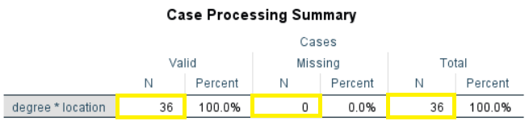

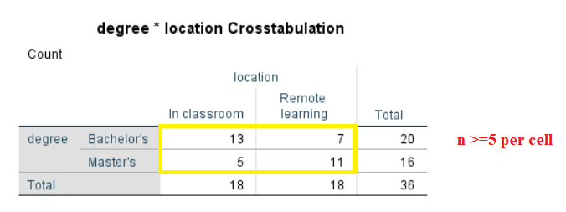

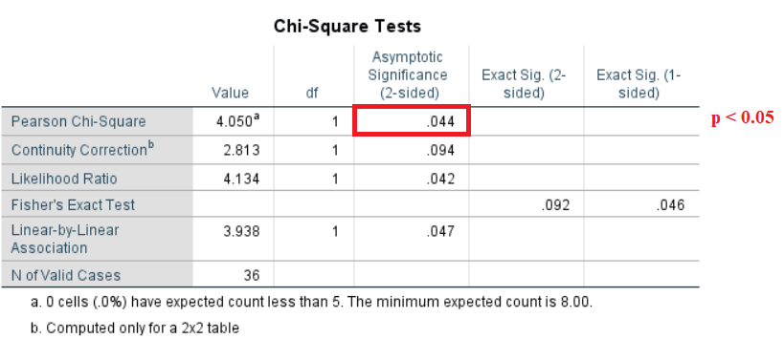

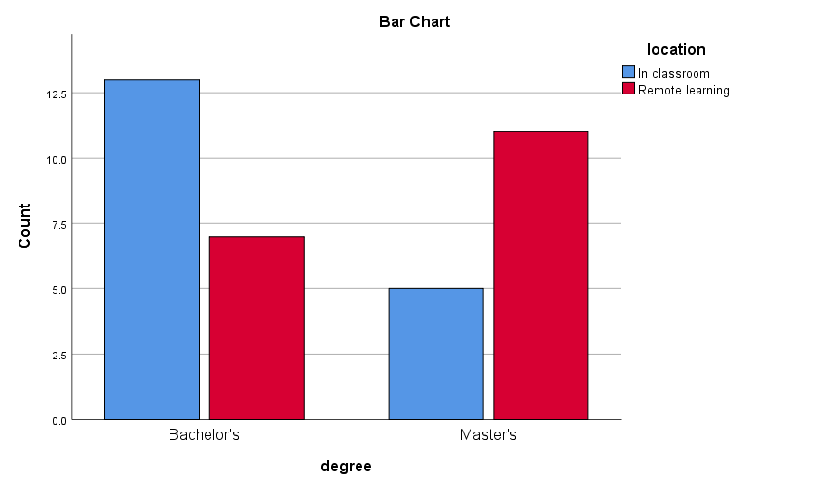

|  |
| --- |
| **Discussion of the Test** |
| **Hypotheses:**  **H0**: There is no correlation between the degree of the students and the type of learning they opted for  **H1**: There is a correlation between the degree of the students and the type of learning they opted for  **Pretest Condition:**   * The value of n is at least 5 per cell in the crosstabulation. Therefore, the pretest condition is met. * Proceed with the Chi Square Test.   **Interpretation of the Results:**   * From the Chi Square test the value of **p =.044** * p < .05 indicates that there is a **statistically significant difference** in the type of learning methodology opted by the degree students.   **Hypotheses resolution:**  **Reject H0**: There is no correlation between the degree of the students and the type of learning they opted for  **Accept H1**: There is a correlation between the degree of the students and the type of learning they opted for  **Graphic Observation:**  Master’s students predominately preferred Remote learning whereas the Bachelor’s degree students predominately preferred Classroom learning  **Documenting Results**  In a survey to improve the availability of student resources, **36 students** from Bachelor’s and Master’s program were asked to record the type of learning (In-Classroom or Remote learning) they prefer. To help the administration staff in making the optimal decision, the relation between the degree program (Bachelor’s or Master’s) and the type of learning methodology is taken into consideration. Since we are comparing two categorical variables, we perform the Chi Square test. Therefore, the primary objective of the study is to run Chi Square to measure the correlation between the above-mention dichotomous variables.  According to the survey of 36 students, we observed a statistically significant difference (**p=.044**, α = .05) in the type of learning opted by Bachelor’s and Master’s students. Out of the 16 master’s students surveyed, most preferred Remote learning (5 Classroom learning, 11 Remote learning), whereas the 20 Bachelor students opted classroom learning as their preferred method of learning (13 Classroom learning, 7 Remote learning).  Since the value of p < .05, we reject H0 and **accept H1**. Therefore, there is a **statistically significant correlation** between the degree of the students and their preferred type of learning. |

|  |
| --- |
| **Exercise Number:** Ch 09 - Exercise 04B |
| **Description of the Test:** Chi-Square |

Warning # 5281. Command name: GET FILE

SPSS Statistics is running in Unicode encoding mode. This file is encoded in a locale-specific (code page) encoding. The defined widths of any string variables are automatically tripled in order to avoid possible data loss. You can use ALTER TYPE to set the width of string variables to the width of the longest observed value for each string variable.

DATASET NAME DataSet1 WINDOW=FRONT.

CROSSTABS

/TABLES=degree BY location

/FORMAT=AVALUE TABLES

/STATISTICS=CHISQ

/CELLS=COUNT

/COUNT ROUND CELL

/BARCHART.

**Crosstabs**

[DataSet1] C:\Users\**Jaya Karthi Booven**\Downloads\Ch 09 - Exercise 04B.sav

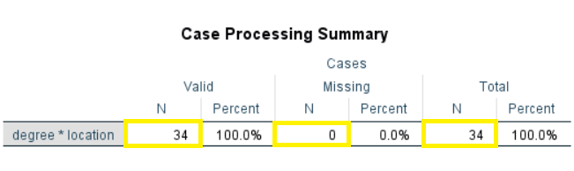

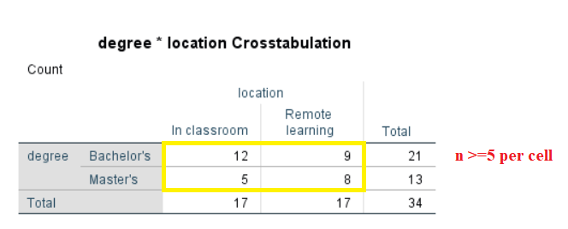

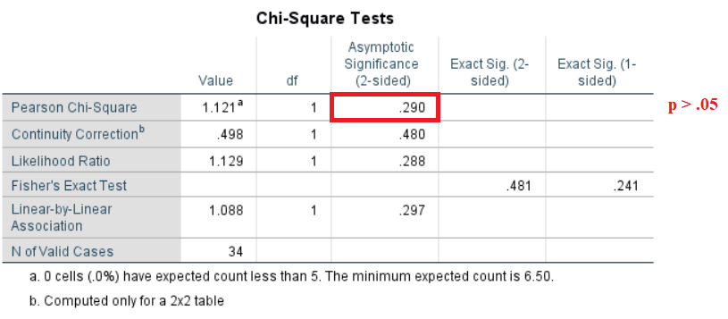

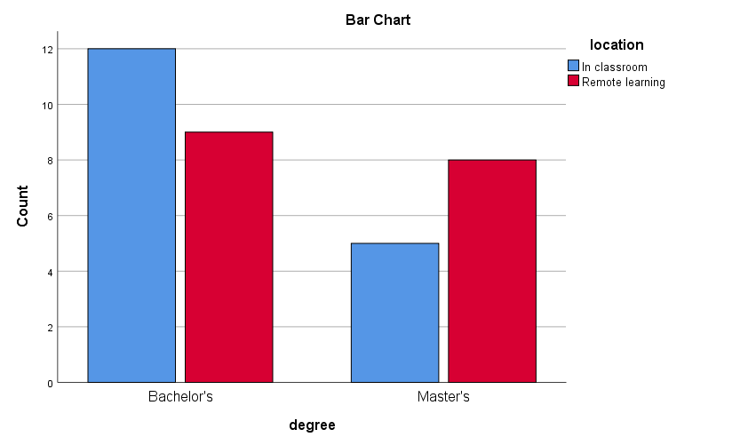

|  |
| --- |
| **Discussion of the Test** |
| **Hypotheses:**  **H0**: There is no correlation between the degree of the students and the type of learning they opted for  **H1**: There is a correlation between the degree of the students and the type of learning they opted for  **Pretest Condition:**   * The value of n is at least 5 per cell in the crosstabulation. Therefore, the pretest condition is met. * Proceed with the Chi Square Test.   **Interpretation of the Results:**   * From the Chi Square test the value of **p =.290** * p > .05 indicates that there is a **no** **statistically significant difference** in the type of learning methodology opted by the degree students.   **Hypotheses resolution:**  **Accept H0**: There is no correlation between the degree of students and the type of learning they opted for  **Reject H1**: There is a correlation between the degree of students and the type of learning they opted for  **Graphic Observation:**  Master’s students predominantly preferred Remote learning whereas the Bachelor’s degree students predominantly preferred Classroom learning  **Documenting Results**  In a survey to improve the availability of student resources, **34 students** from Bachelor’s and Master’s program were asked to record the type of learning (In-Classroom or Remote learning) they prefer. To help the administration staff in making the optimal decision, the relation between the student program (Bachelor’s or Master’s) and the type of learning methodology is taken into consideration. Since we are comparing two categorical variables, we perform the Chi Square test. Therefore, the primary objective of the study is to run Chi Square to measure the correlation between the above-mention dichotomous variables.  According to the survey of 34 students, we observed no statistically significant difference (**p=.290**, α = .05) in the type of learning opted by Bachelor’s and Master’s students. Out of the 13 master’s students surveyed, most preferred Remote learning (5 Classroom learning, 8 Remote learning), whereas the 21 Bachelor students opted classroom learning as their preferred method of learning (12 Classroom learning, 9 Remote learning).  Since the value of p > .05, we reject H1 and **accept H0**. Therefore, there is **no statistically significant correlation** between the degree of students and the type of learning they opted. |